**DEEP LEARNING NOTES**

**ARTIFICIAL NEURAL NETWORK**

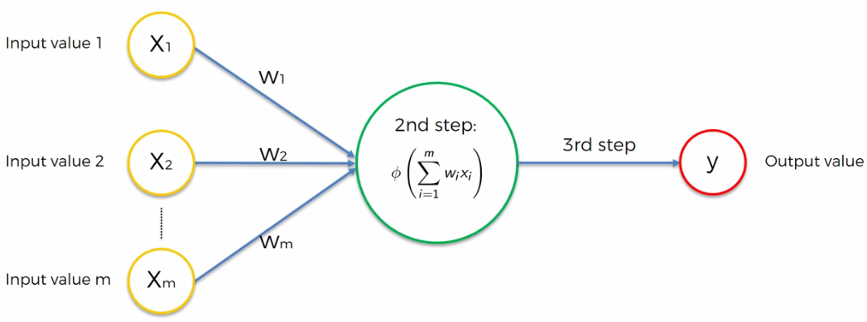

**ACTIVATION FUNCTIONS**

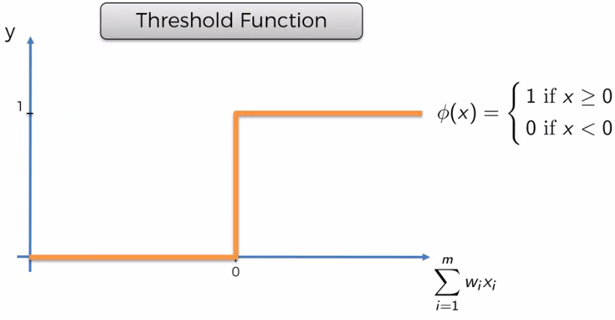

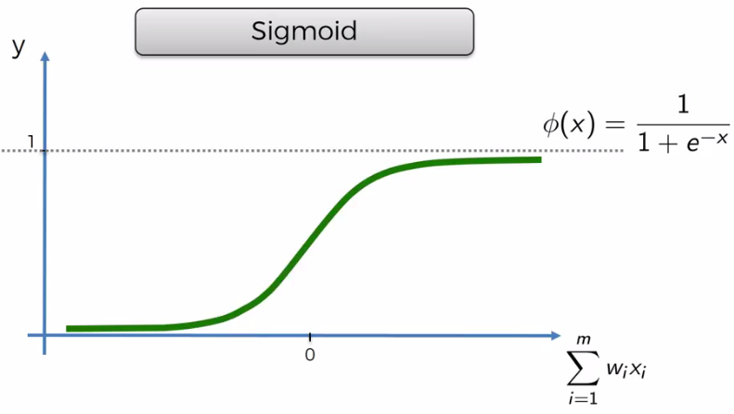

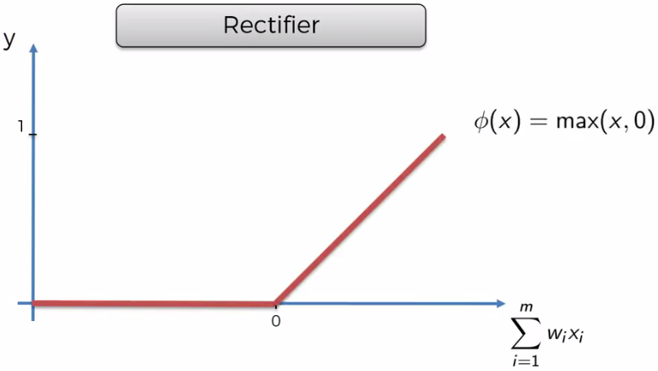

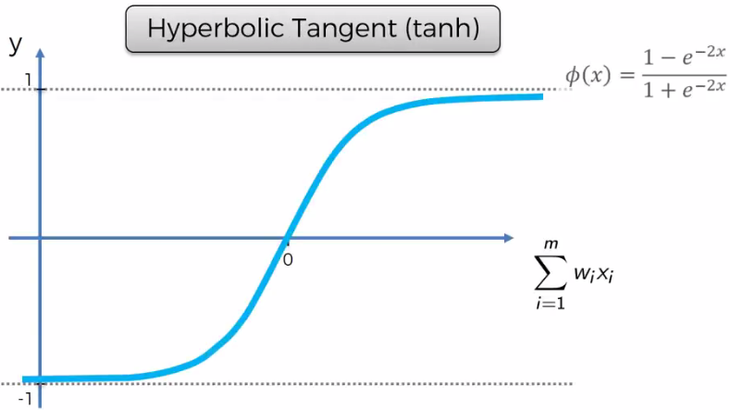

**COMMON WORKING OF THE NEURAL NETWORK**

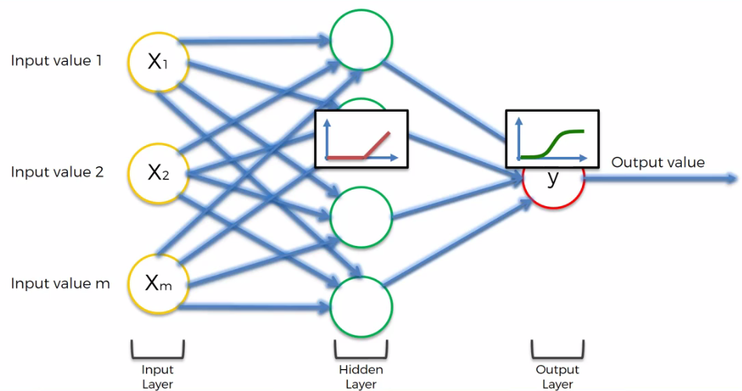

**Here rectifier activation function is applied to the hidden layer and sigmoid function is applied at the final output value.**

***SIDE NOTES:***

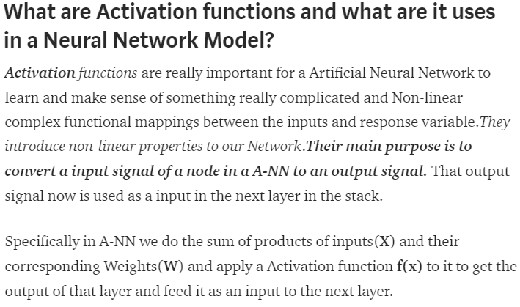

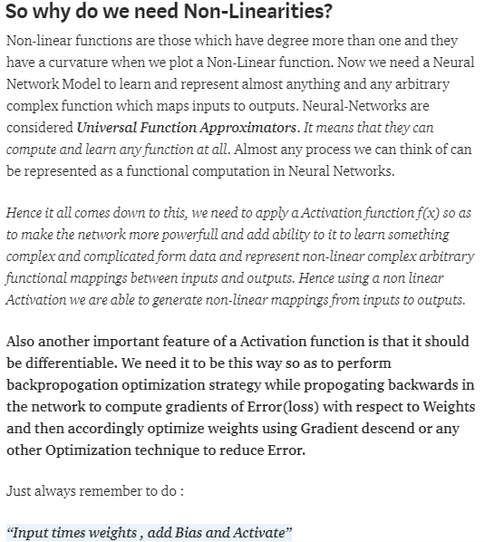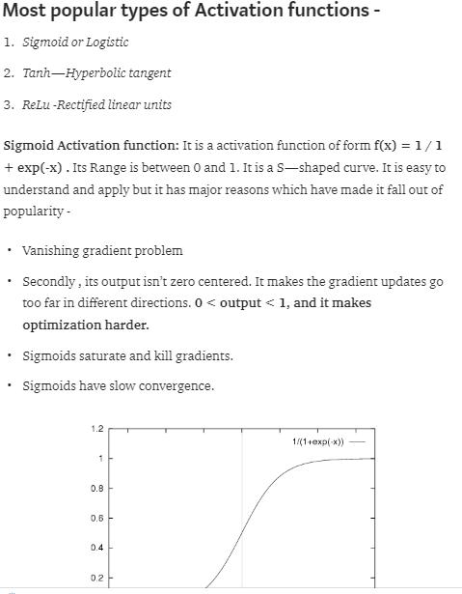

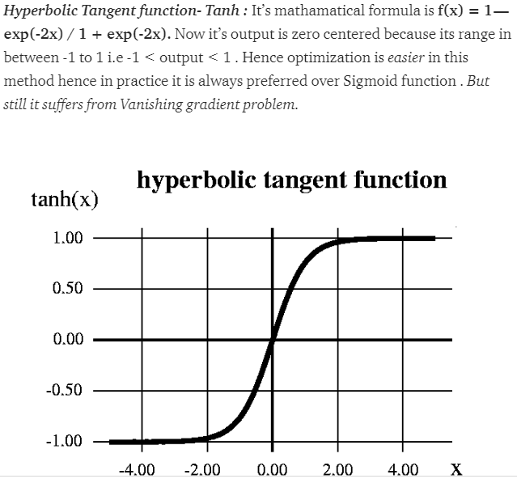

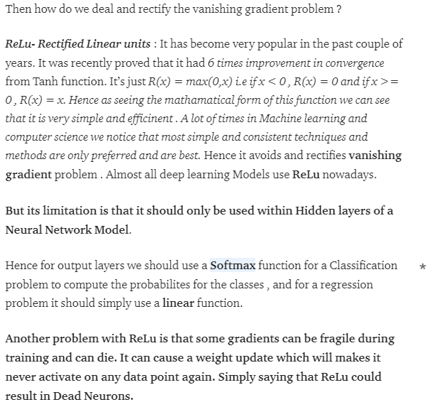

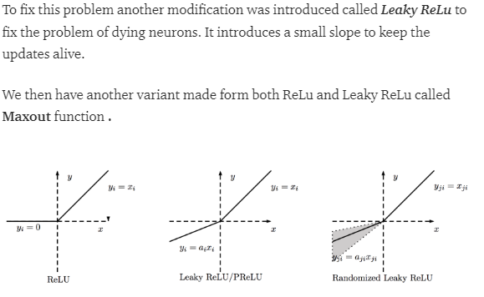

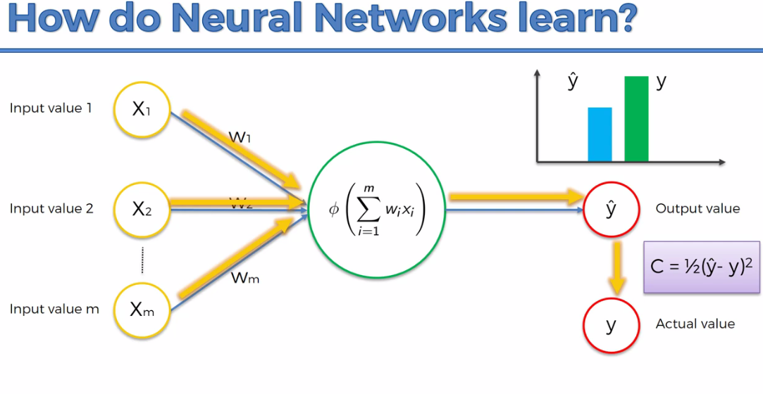

Here C is the cost function associated with the model i.e. The difference in the error that is to be improved to get the right prediction.

Cost Function is something which needs to be minimized.

The lower is the cost function the more is the y is getting nearer to y^ .

**EXTRAS FROM STACKOVERFLOW:**

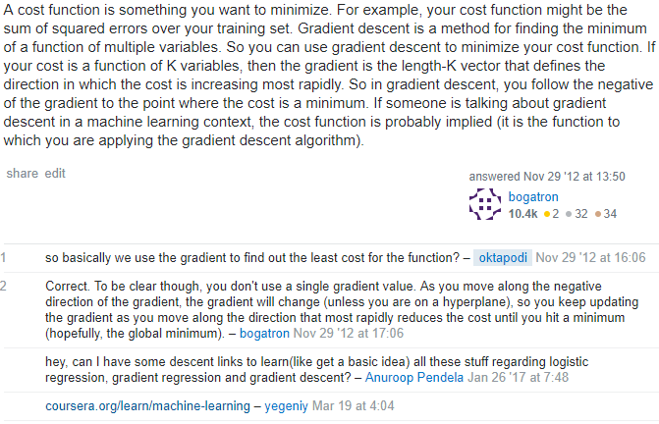

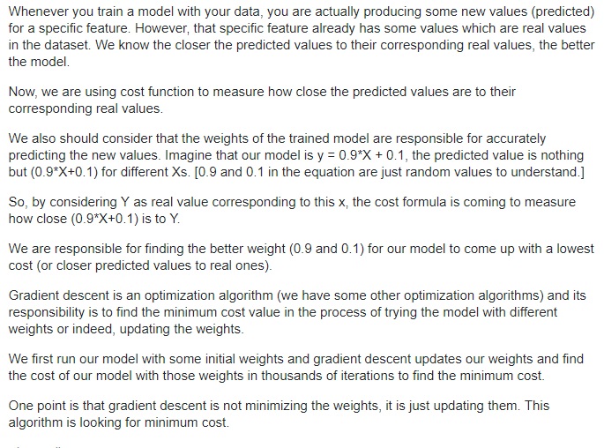

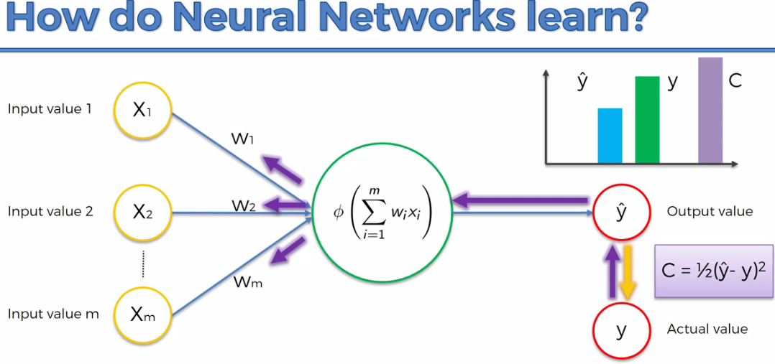

This is how the above cost function changes the value(here the value is the change in the input weights).

Here the same input value is given iteratively and progressively to the input and this would update the weights so that the cost function reduces (~0) not exactly zero but nearer to zero.

The above process which is going on is called Backpropagation where the weights are updated iteratively to minimize the cost associated with it.

**GRADIENT DESCENT**

**How the weights are adjusted. So gradient descent is the method by which the weights are adjusted accordingly.**

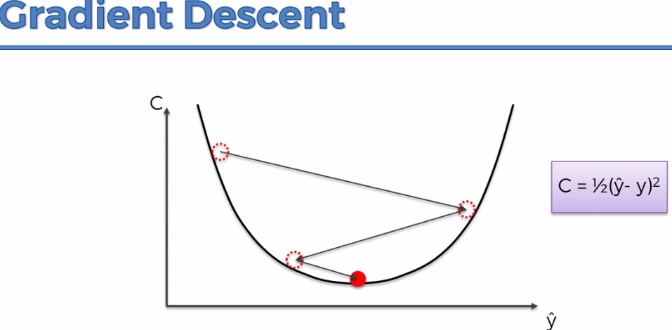

**Here at each red spot gradient is calculated and we move down till the optimal value is reached.**

**Above the graph is CONVEX graph and the gradient descent method is used for the solving the problems with CONVEX graph**

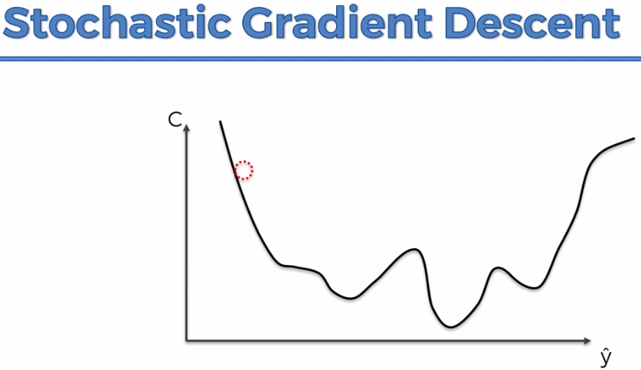

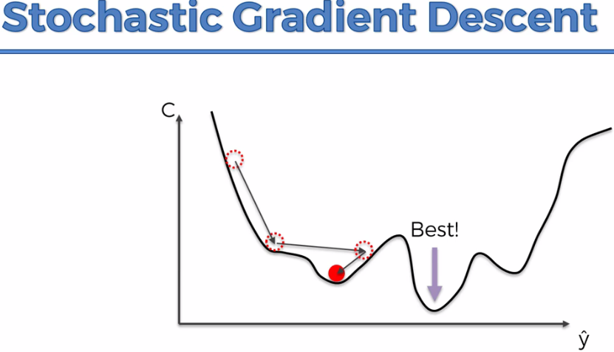

**So if many local minimas are present then we use Stochastic Gradient Descent else we will be using Gradient descent.**

**Stochastic Gradient Descent is the lighter algorithm as compared to Gradient Descent, since many rows are taken at a time in Gradient Descent and weights are calculated whereas in the case of Stochastic Gradient Descent only one row is taken at a time and weights ae adjusted.**

**EXTRA RESOURCES**

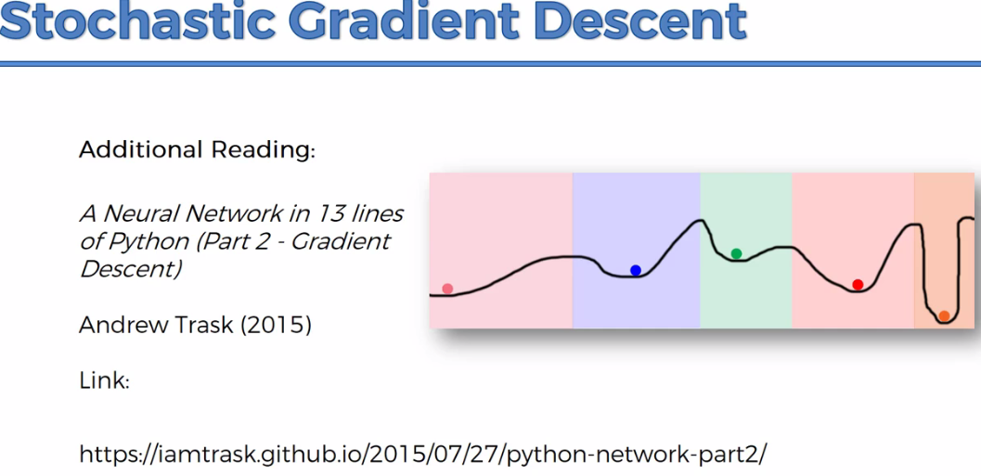

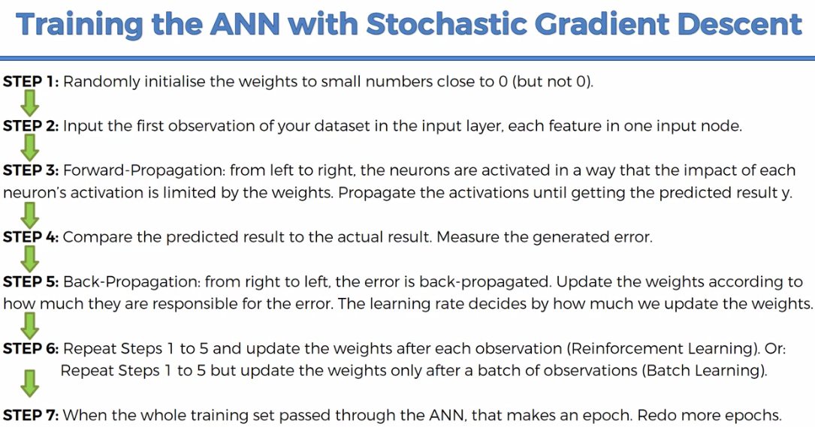

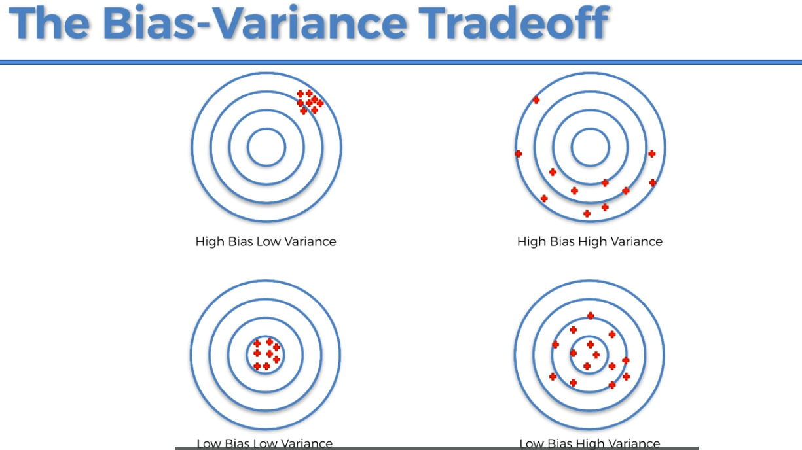

Because of bias variance tradeoff we are getting different accuracy in the model while it is being trained at different times.

**DIFFERENCE BETWEEN GRADIENT DESCENT AND BACKPROPAGATION**

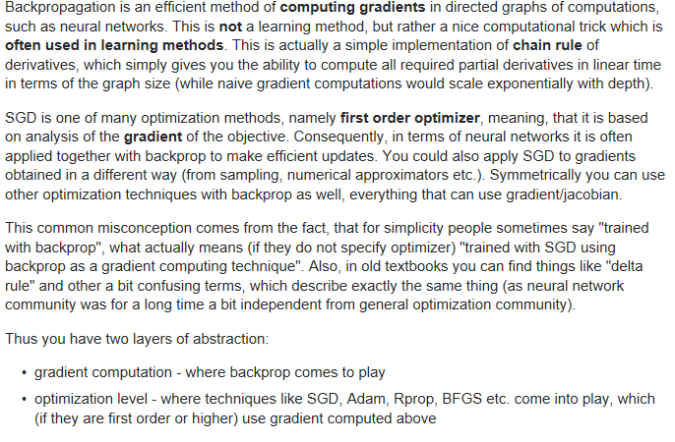

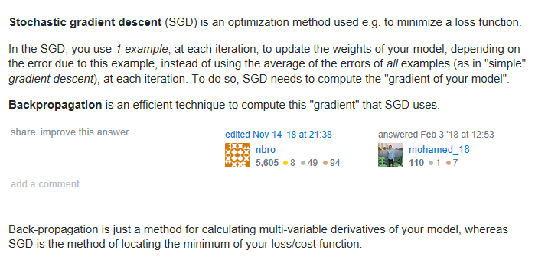

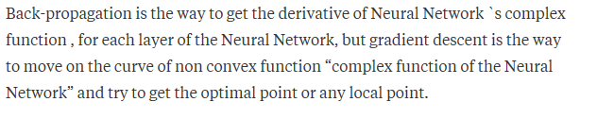

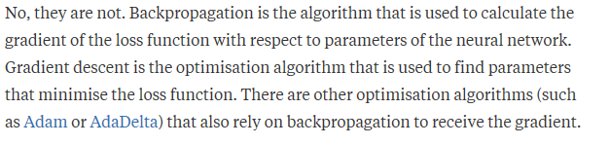

**WHY WE ARE SQUARING THE ERRORS RATHER TAKE THE DIFFERENCE AT THE COST FUNCTION**

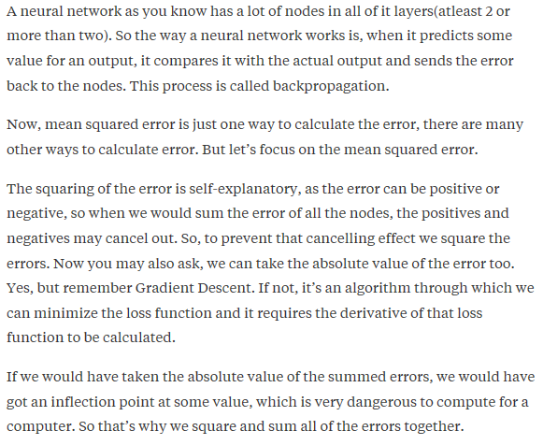

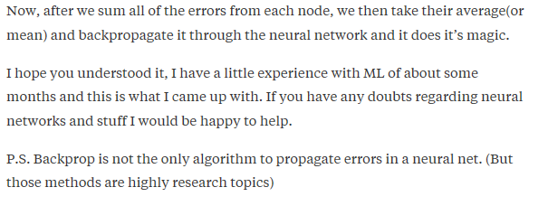

**Important points to ponder**

<https://math.stackexchange.com/questions/1621759/neural-network-cost-function-why-squared-error>

**Types of cost functions used in NN**

[**https://stats.stackexchange.com/questions/154879/a-list-of-cost-functions-used-in-neural-networks-alongside-applications**](https://stats.stackexchange.com/questions/154879/a-list-of-cost-functions-used-in-neural-networks-alongside-applications)

Gradient Descent or batch gradient descent– How the weights are actually adjusted or updated

Whenever we use the cost function as mean squared error we have to use gradient descent because the cost function will have the parabolic path or in the convex form… we term this as convex space problem.

Now if we are using the cost function as other than mean squared error we might end up in getting more convex breaks than the simple convex or parabolic form in that case we have to stochastic gradient descent, because if we use gradient descent we might end up in local minimum which in the case of convex we don’t find

<https://iamtrask.github.io/2015/07/27/python-network-part2/>

neuralnetworksanddeeplearning.com/chap2.html

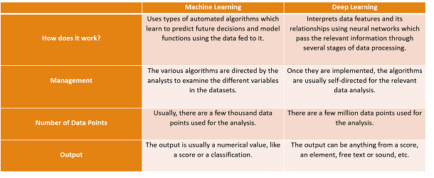

**ANN – Practical**

**To predict whether the customer will leave the bank or not ?**

**It is a classification problem with a binary output.**

So we start with a sample dataset which the particular bank has been recording for years now

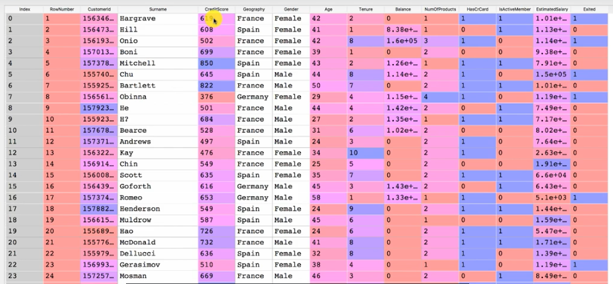

So the dependent variables are:

~~Rownumber~~

~~Surname~~

~~Customerid~~

Credit score

Geography

Age

Tenure

Balance

Noofproducts

Hascreditcard

Isactivemember

Estimatedsalary

**Exited – final result that is to be predicted**

**Step1. Import the necessary library**

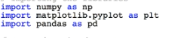

**Step2. Importing the dataset and dividing into input and output**

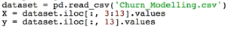

**Step3. Check whether the dataset is having a categorical variable or not ? if any categorical data present then we have to encode them.**

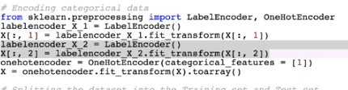

**x=x[:,1:]** #this is used to remove the dummy variable trap

**Additional material regarding types of variables like ordinal and categorical variables**

[**https://stats.idre.ucla.edu/other/mult-pkg/whatstat/what-is-the-difference-between-categorical-ordinal-and-interval-variables/**](https://stats.idre.ucla.edu/other/mult-pkg/whatstat/what-is-the-difference-between-categorical-ordinal-and-interval-variables/)

**Why do we need dummy variables ?**

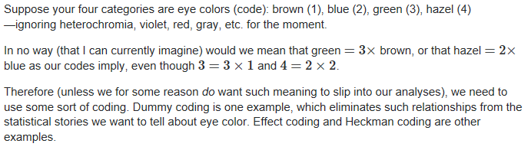

**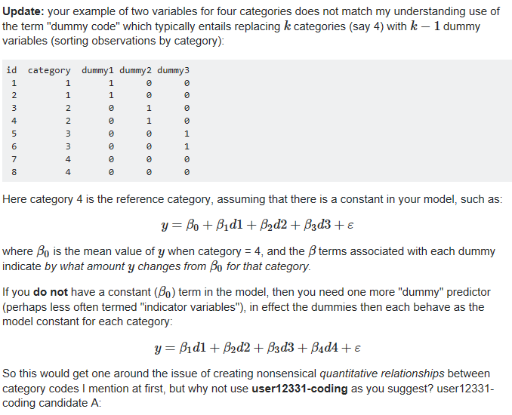  
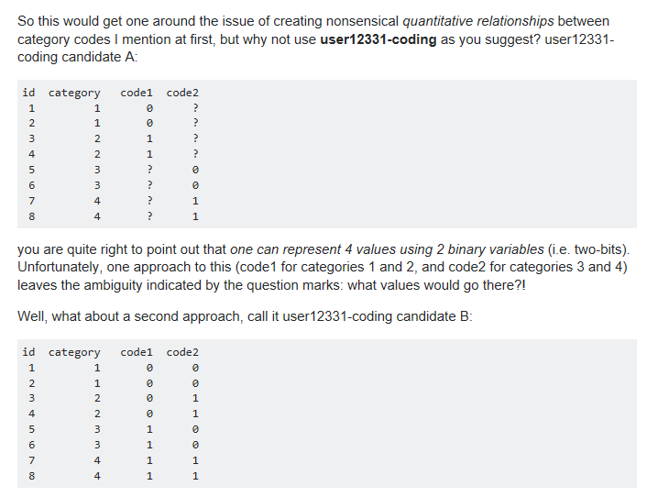**

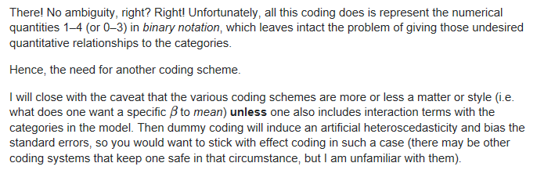

**Why do we need dummy variable ?**

[**https://www.moresteam.com/WhitePapers/download/dummy-variables.pdf**](https://www.moresteam.com/WhitePapers/download/dummy-variables.pdf)

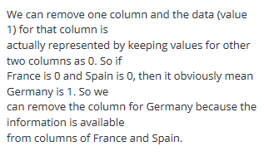

**Step4. Splitting the dataset into testing dataset and the training dataset**



**Step5. Feature Scaling**



Feature scaling is done to avoid complex computations so as the model can be trained with an ease. Here the keras library does the necessary feature scaling by itself which make our model train faster.

**<******************************DATA PREPROCESSING STEP OVER*************************************>**

**Step6. Building the main NN model –importing the libraries required**

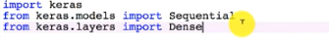

Sequential is used for initializing the NN

Dense is used to create the layers in the NN

**Step7. Initializing the deep learning model**

There are 2 ways of initializing the deep learning model – by defining the computational graph , by defining the sequence of layers

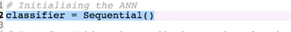

**Step8. Adding layers to the model**





**Step9. Adding the output layer**



Since our model is predicting the binary output so output_dim = 1 , and since it is not a multi classification problem so we are using activation = sigmoid.

**Step10. Compiling the neural network**



Here since the problem is a binary classification problem so we are using loss = binary_crossentropy and optimizer = adam , do stochastic gradient descent algo

**STEP11. Fitting the ANN to the training set**



**STEP12. Making the predictions**

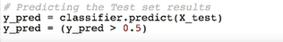

**So this will give you the ultimate result that who all will leave the bank.**

**For calculating the accuracy we will be making the CONFUSION MATRIX**

<https://www.dataschool.io/simple-guide-to-confusion-matrix-terminology/>

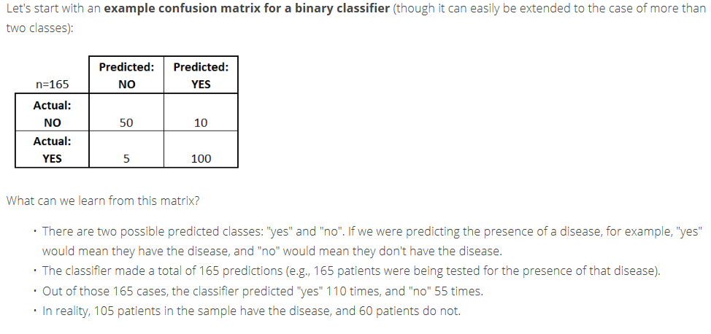

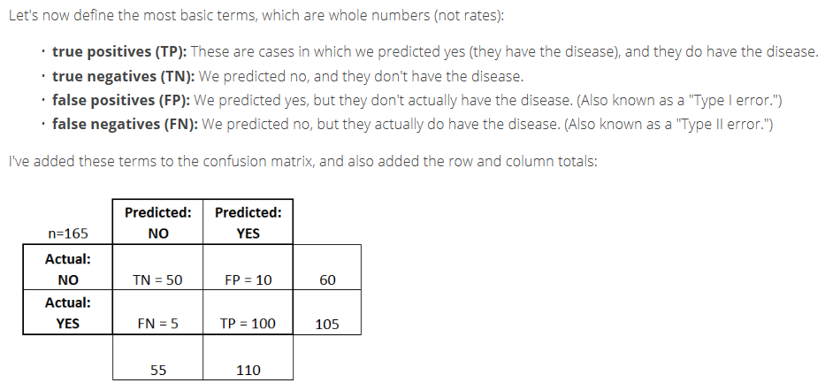

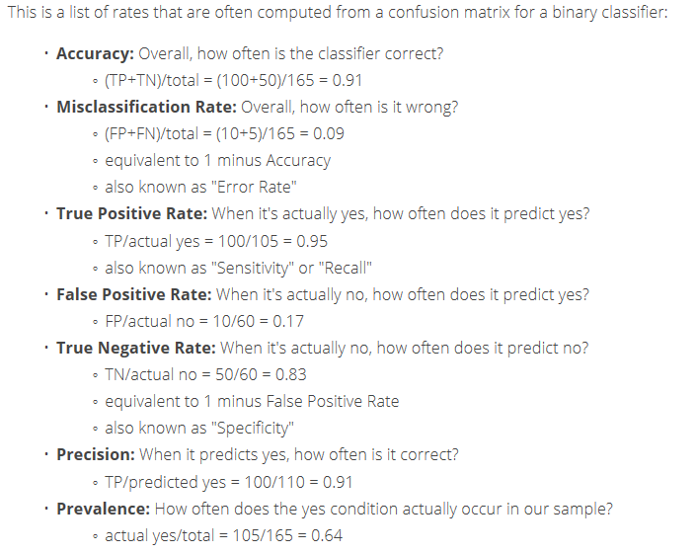

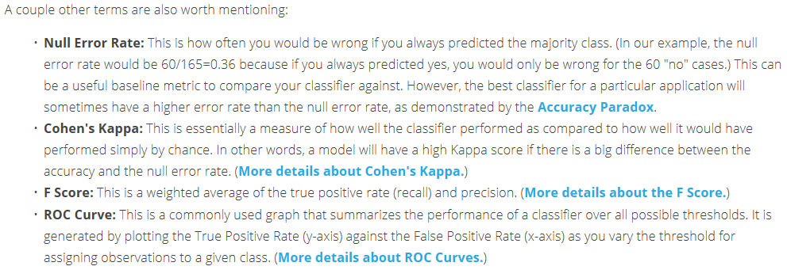

**Step13. Make a confusion matrix**

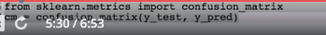

**Extra materials** [**https://github.com/marcotcr/lime**](https://github.com/marcotcr/lime) **-for explaining the model predictions**

**Step14. Prediction on the new single dataset**

"""home work

Geography: France

Credit Score: 600

Gender: Male

Age: 40 years old

Tenure: 3 years

Balance: $60000

Number of Products: 2

Does this customer have a credit card ? Yes

Is this customer an Active Member: Yes

Estimated Salary: $50000"""



**Performance tuning**

For the performance tuning we will be using the K-cross validation.

**Step1.**

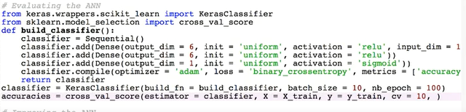

Also add n_jobs = -1 into accuracies

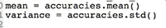

**More on performance tuning use DROPOUT to prevent the model from overfitting – high accuracy on training and low accuracy on testing set**

**Step2.(optional) Applying DROPOUT**

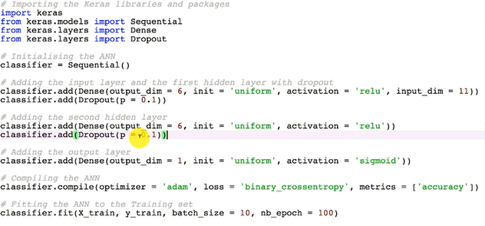

**Step3.(Hyper parameter tuning)**

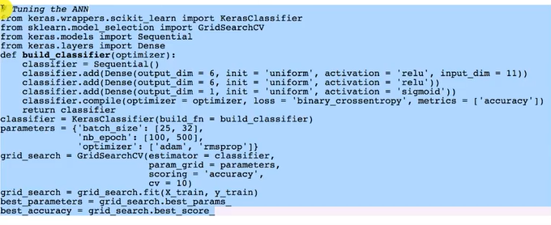

**CONVOLUTION NEURAL NETWORK(CNN)**

<https://www.superdatascience.com/the-ultimate-guide-to-convolutional-neural-networks-cnn/>

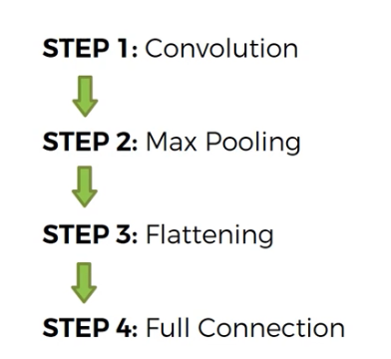

**CONVOLUTION OPERATION**

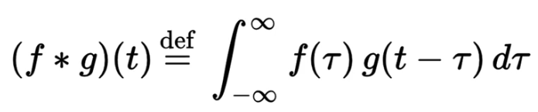

It is simply the combined integration of 2 functions or we can say that how a one function modifies the other function

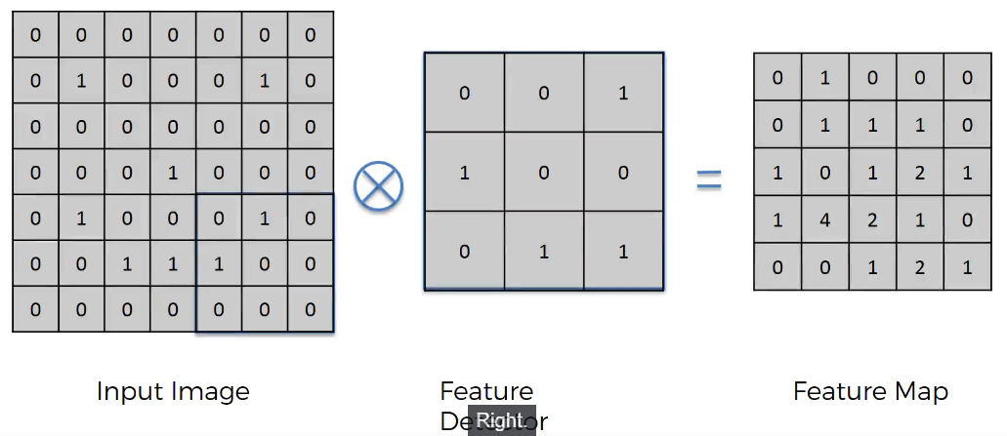

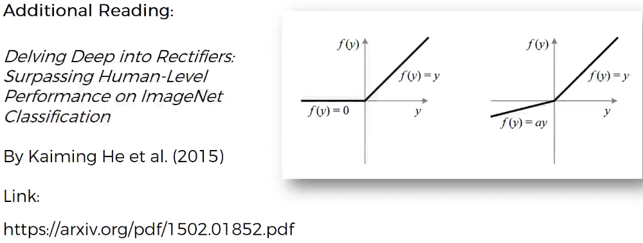

All the model must have the SPATIAL INVARIENCE, which means that the model does not care about where the features are again or how the features are present etc and to achieve this we are using the pooling layer

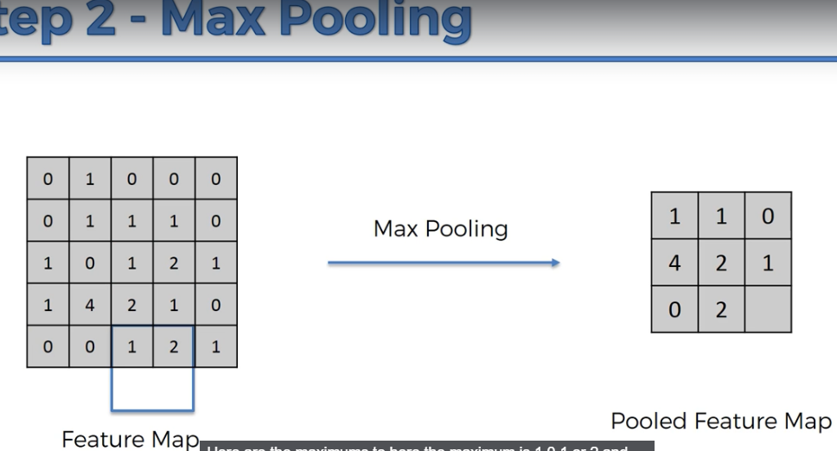

Main points:

Preserving the features – more efficiency

Reducing the size – more performance

Prevents overfitting – since the parameters are less

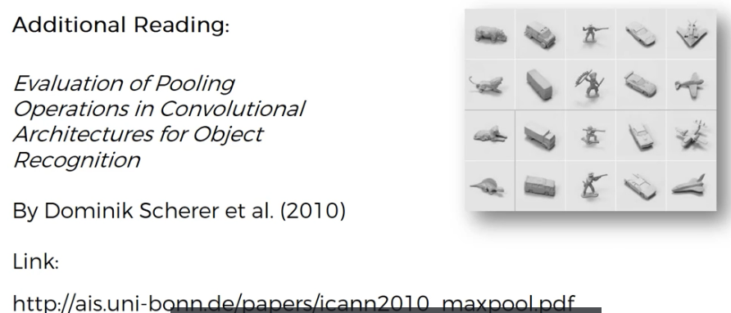

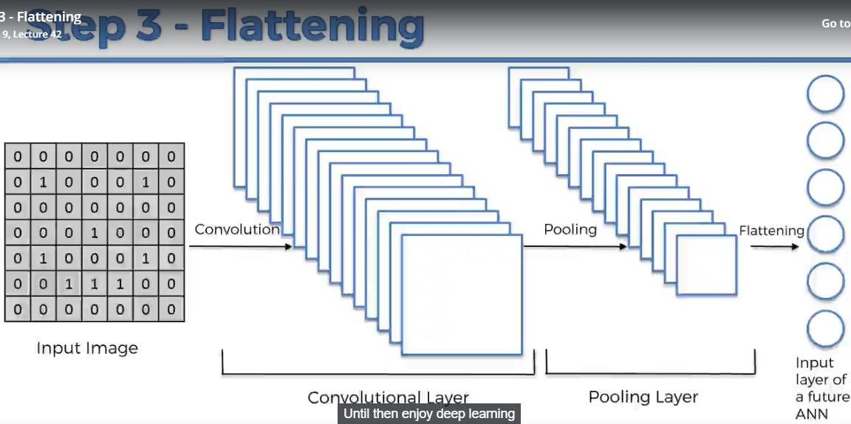

Summary

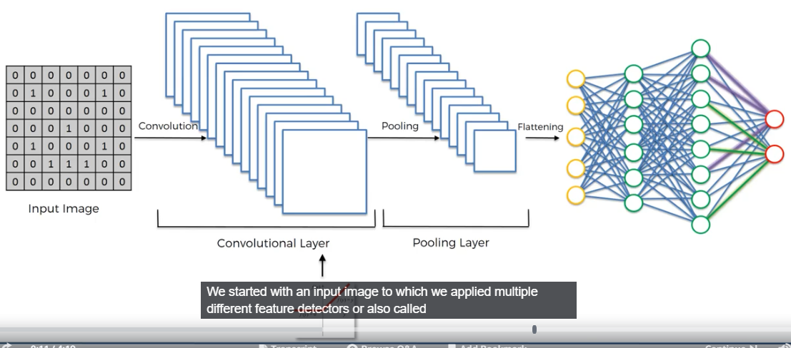

The feature detector and the feature map are also trained at the same time as that of gradient descent.

<https://adeshpande3.github.io/The-9-Deep-Learning-Papers-You-Need-To-Know-About.html>

resume reference <https://adeshpande3.github.io/adeshpande3.github.io/resume.pdf>

**softmax and cross entropy**

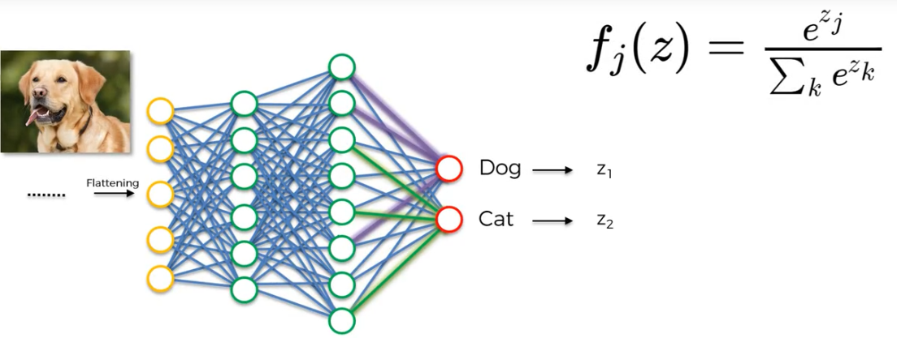

Normally during the prediction of the values(whether its dog or a cat) there is no connection between the 2 values, i.e they don’t have to be add to 1. So to bring the values add to 1 we are using the softmax function which will do the work for us i.e(it squashed the values into a range of 0,1)

How to use the cross entropy ?

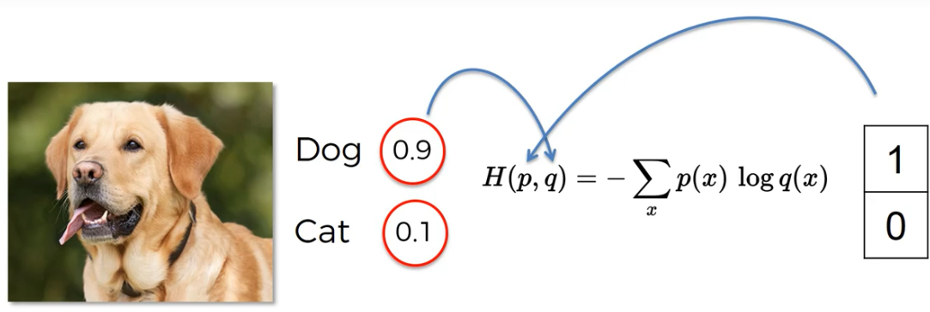

Significance of the cross entropy

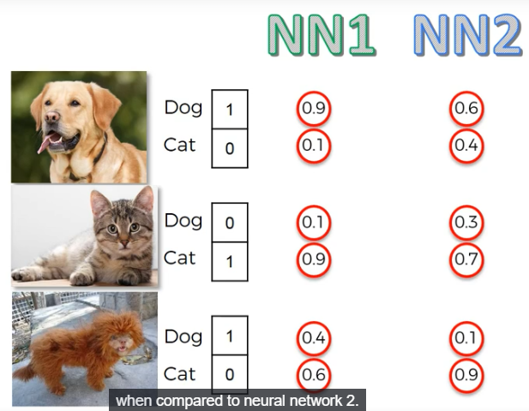

Tabulating the above values

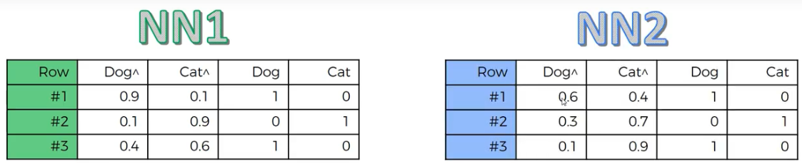

Classification error (in both cases) = 1/3 = 0.33

But if we look at the predicted values we can see that the NN1 is performing better than NN2

Mean squared error = 0.25 , 0.71 resp.

Cross entropy error = 0.38,1.06 resp

So if we look at the above values we gets to know that the cross entropy will make the network reduce or rectify the errors more faster.

Cross entropy is basically used in Classification problem

Mean squared error is used in Regression related problems

**Project**

In CNN there is no need of data pre processing since that step is done manually, so only the image augmentation is to be done that will be done during the process of the making of the model.

**Step1. Importing the necessary packages**

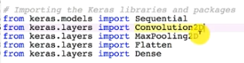

**Step2. Initializing the NN**

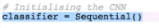

**Step3. Convolution layer**



in the above code (32,3,3) corresponds to 32 filters of 3x3 size and the input_shape = 64x64x3 corresponds to 3 channels of 64 x 64 size

note: in case of tensorflow backend the input is (64x64x3) in case of theano backend it is (3x64x64)

activation is ‘relu’ for bringing the non linearity in the model

**Step4. Pooling step (max pooling step)**

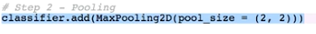

**A separate note: usually in convolution step stride is taken as 1 but in case of pooling the stride can vary. In pooling(max pooling) the max from the cube(pool) is taken while in convolution blockwise multiplication is done.**

**Normally pool size is 2x2**

**Step5. Flattening step**



**Step6. Full Connection layer**

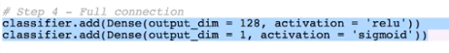

Summary of what is being done till now

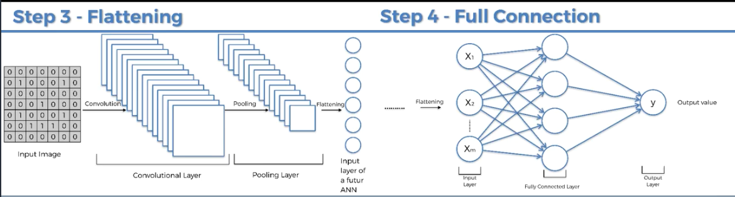

**Step7. Compiling the CNN**



**Step8. Fitting the image to the CNN(Image processing)**

Here we will be using the image augmentation to prevent the overfitting of the model

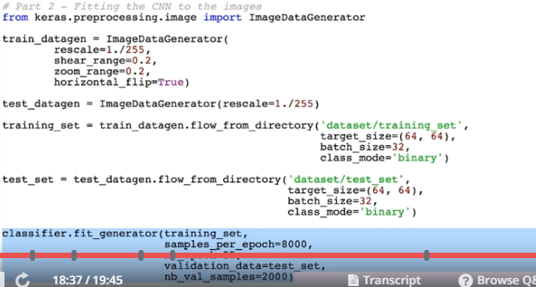

**Step9. Add more layers to the model**

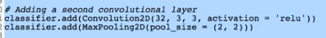

**\*\*\*\*\*\*\*\*\*\*\*\*\*\*\*\*\*\*\*\*\*\*\*\*\*\*\*\*\*\*\*\*\*\*\*\*\*\*\*\*\*\*\*\*\*\*\*\*\*\*\*\*\*\*\*\*\*\*\*\*\*\*\*\*\*\*\*\*\*\*\*\*\*\*\*\*\*\*\*\*\*\*\*\*\*\*\*\*\*\*\***

**Extras:**

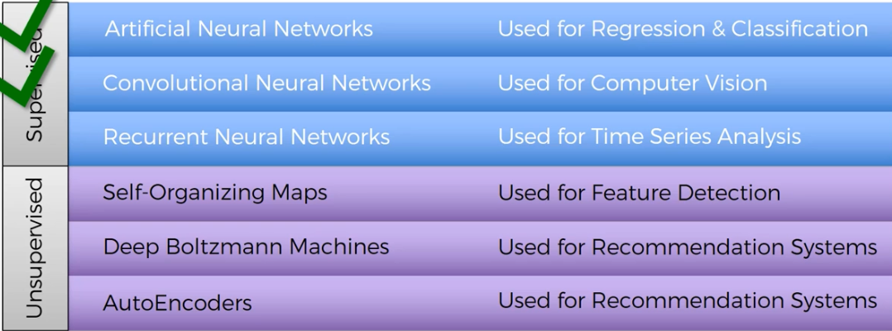

**Recurrent neural networks(RNN)**

**Analogy of the brain with the algorithms of Deep Learning**

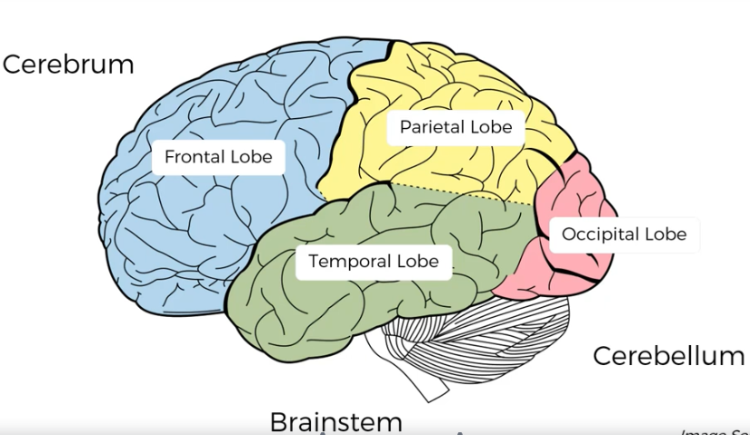

The main break through with the ANN is that it can learn from the prior experiences and that is because of the presence of the weights associated with it and this weights once get initialized will be in the form of memory which allows the model(ann) for prediction etc etc. So in nutshell WEIGHTS ARE THE LONG TERM MEMORY

So Temporal Lobe = weights

Occipital Lobe = vision related (cnn)

and RNN is like a short term memory, which can remember few past instances

So

Frontal Lobe = RNN(short term memory)

Temporal Lobe = Cognition memory

Parietal Lobe = responsible for sensation and perception and constructing a spatial coordination to representa world around us

**Conversion of ANN into RNN**

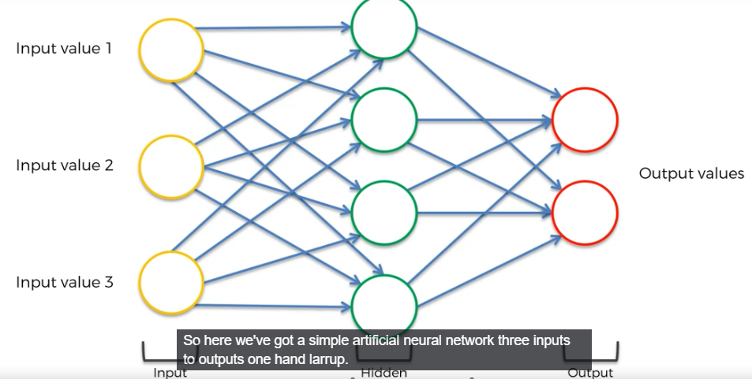

First thing to do is to squash it

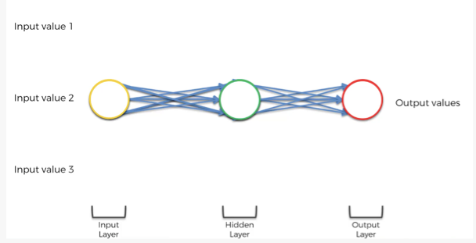

Change the multiple arrows into single one

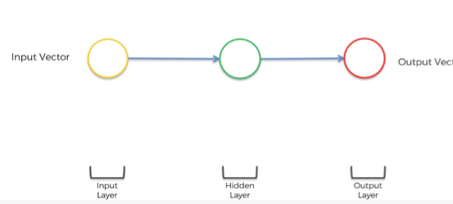

Twisting it to make it vertical

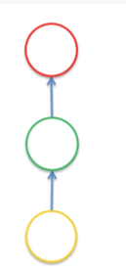

Adding a line to represent the temporal loop

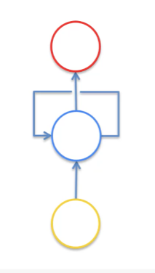

Unrolling the loop part

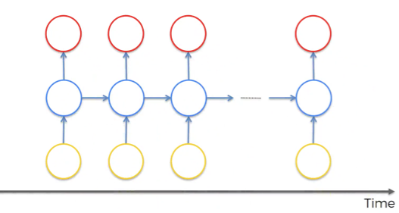

Now each circle represents not only 1 neuron, but a whole layer of neuron

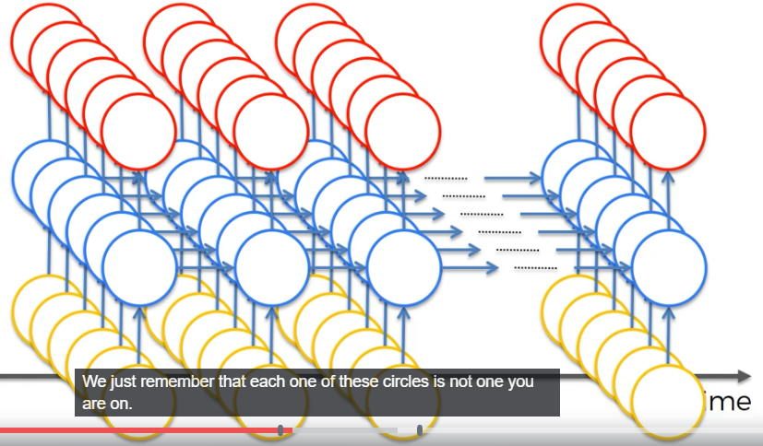

Types of RNN’S and applications

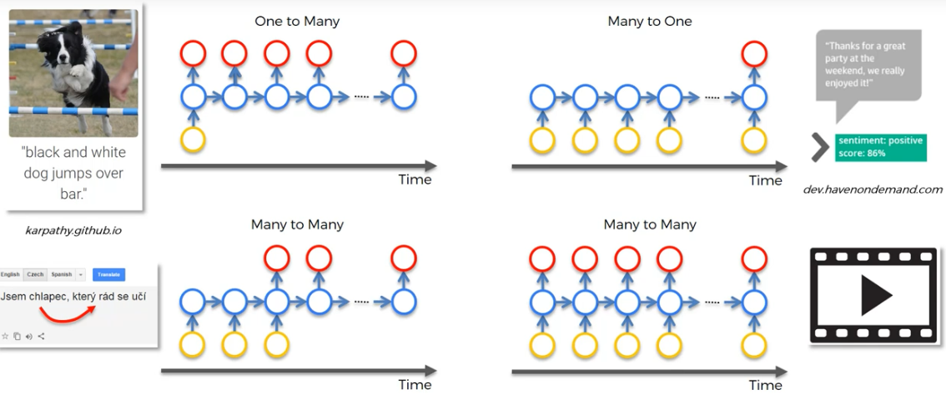

**VANISHING GRADIENT PROBLEM**

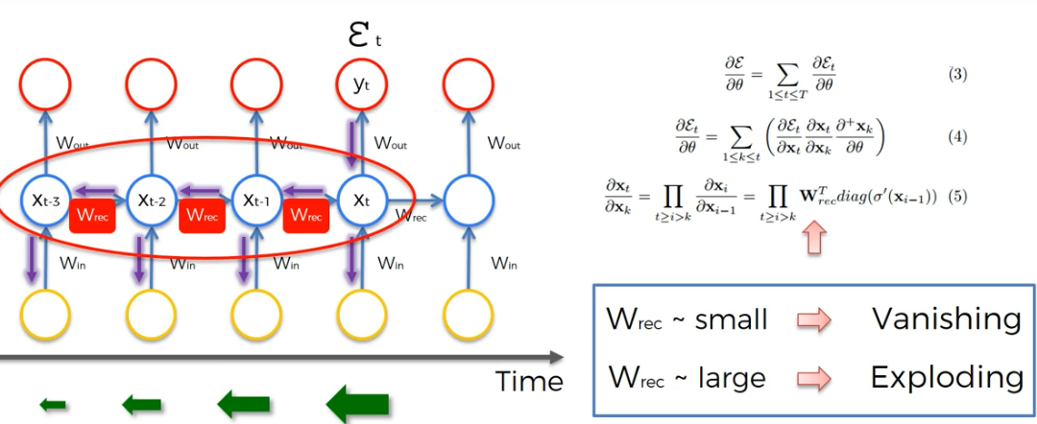

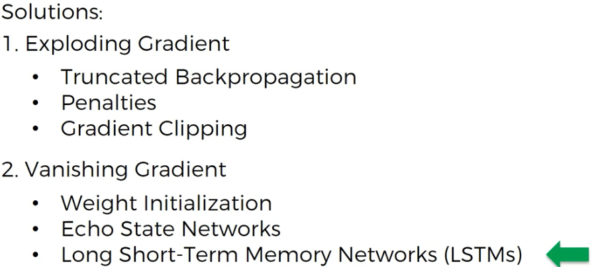

**LSTM(LONG SHORT TERM MEMORY)**

**An excellent blog for RNN**

[**http://colah.github.io/posts/2015-08-Understanding-LSTMs/**](http://colah.github.io/posts/2015-08-Understanding-LSTMs/)